Name: Frank Wright | Course Number/Title: EDU 4990 Final Internship
Total Length of Lesson: 47 min | Grade Level: 1st grade
Subject Area/Topic of Lesson: ELA – common and proper nouns | Total number of P-12 students: ___18__ Number of ELL students: __2___  Number of ESE students excluding Gifted: __3___ Number of Gifted students: __2___
FL Standards (Academic Standards)  (Write the benchmark number and description.) Find these on the FLDOE website or CPalms. http://www.cpalms.org/Standards/FLStandardSearch.aspx.  Include standards to integrate across subjects. Example: Reading, Writing, Social Studies; Math, Writing, Science | Student Achievement (Learning) Objectives (SAO)  The objective must match the FL Standards. Objectives are developed by unpacking the standards and creating learning targets that chunk the knowledge into smaller pieces.  The objective and SAO must match the FL standard.  Example: The students will demonstrate understanding of mixed numbers and improper fractions by drawing models of equivalent mixed numbers and improper fractions with an 80% mastery level.  (The objective should be aligned with the summative assessment.) |  |  | Summative Assessment/Evaluation  This must assess the students’ mastery of the objective/standard. Examples: final project, paper test, report, chapter test, etc. Be sure that this assessment directly links to the objective and standards. This section will be copied at the bottom of this this lesson plan to show the sequence of instruction. Organize learning targets into performance scales.  Attach a copy of the summative assessment to this lesson plan.
LAFS.1.L.1.2 Demonstrate command of the conventions of standard English capitalization.  Capitalize dates and names of people. | Students will be able to identify the difference between common and proper nouns and capitalize the proper nouns on a test with 75 % accuracy. |  |  | Students will take a noun test. They must achieve 75% to show mastery.
Possible misconceptions for this lesson and strategies to address misconceptions  Gather information from pretests, talking to CT, common content area misconceptions, suggested misconceptions from teacher resource materials. | Students may get confused with names such as “Grandma” when used in a sentence like “My grandma came to visit.” We will talk about when the name is used to call someone and when it's not. It will be confusing.
ESOL strategies specific to the P-12 students in your class and content of the lesson  You must include these instructional strategies under the assumption that there are P-12 ELL students in the classroom. List the ELL stages of the students. ELL instructional strategies must support the objectives of this specific lesson. Align the instructional strategies to the critical content of the lesson. Please list stages, code and the description given. | A6-Provide alternative instruction whenever the class lessons are extremely difficult for the LEP student.  A10-Keep directions short and simple.  A13-Allow LEP students to use bilingual dictionaries (directions in L1)  B9-Choose reading and writing activities that activate the prior knowledge of the students.  There are two ELL students – both in stage two.
Materials/Tech/Eqmt/E-Lrng  List all including specific titles of any texts and links to any videos or other media. All materials must be at the appropriate grade level, critical content level, and level of rigor. | Giant sticky note  journal entry sheets- common and proper nouns  Crayons  white boards and markers  Graphic organizer – Proper Pete and common cat  Summative assessment
Vocabulary  Necessary for P-12 students to understand the critical content of the lesson.  Be sure to list words and definitions. | character- a person or animal in a story  setting- where the story takes place  events- what’s happening in the story
Instructional Strategies  List various specific instructional strategies used throughout the lesson. (whole group, small group, centers, specific graphic organizers, paired discussion, think-alouds) | Whole Group, pairs, graphic organizer
Differentiated Instruction/  Meeting the Needs of All Learners  Address P-12 ELLs, students with difficulties, and advanced students. Remember critical content, process, and product. Include P-12 student first names if used in any clinical experience or with a hypothetical class. (no last names) | P-12 ELL Students (include ELL level)  Content, Process or Product | P-12 Students with difficulties  Content, Process or Product |  |  | P-12 Advanced Students  Content, Process or Product
 | Process: Both ELL students are level 2. Jose and Marta be given the guided practice sheet with directions in Spanish. Since this may be a hard concept for them, I will use more concrete examples such as dog, Fido (my named dog) and book, The Very Hungry Caterpiller (named book). | Process: I will use more concrete examples such as dog, Fido (my named dog) and book, The Very Hungry Caterpillar (named book) for Cole, Shontae, and Marcus. |  |  | Product: Lacey and Donte will be asked to create sentences with both common and proper nouns and be asked to identify the nouns as such within the sentence. They will share their sentences under the document camera for the class to discuss. During the independent practice, they will be asked to write more complex sentences.
Introduction to new critical content/Review of previous critical content/P-12 Student Engagement  Plan for approximately 10% of the total lesson to be devoted to this area. This is used to activate background knowledge, introduce vocabulary (if needed at this time), and create excitement about what is about to be taught. Use videos, games, graphic organizers, etc… | Introduce graphic organizer Proper Peter vs common cat Review nouns. What is a noun? A noun is a person place or thing...  Can you give me an example of a noun? Let’s find the nouns in this sentence. Kimmy put the dog on a leash to go outside.  Today we are going to learn about two different types of nouns. |  |  |  |  | Estimated Time: 2 min.
 | Higher Order Questions  List questions and identify level of taxonomy. The questions must be grade level appropriate and ABOVE the comprehension/understanding level.  http://www.fctl.ucf.edu/teachingandlearningresources/coursedesign/bloomstaxonomy/ |  | Turn to your partner and create a sentence with three nouns in it. (Create)
Instruction/Explanation  When using the 5E model, Explanation and Exploration are reversed.  - Explain  - Model/Demonstrate  What instruction will you provide to impact P-12 student learning and create rigor through complexity and autonomy? | List the FL Standard(s) and learning targets in this section:  LAFS.1.L.1.2 Demonstrate command of the conventions of standard English capitalization.  Capitalize dates and names of people. |  |  |  |  | Estimated Time:  10 min,
Did you know that there are two types of nouns? They are called common and proper nouns.
Common noun - IS a person, place, thing, or animal -common nouns are NEVER capitalized
Proper noun NAMES a person, place, thing, or animal - are always capitalized - are generally the special name for a specific person, place or thing
Go over Proper Pete vs common cat chart
Proper vs common practice chart -come up with nouns common or proper, decide which category to put it in , find a matching noun for the other column -eg Curious George- proper - What is he ? ( a monkey- common) -eg water bottle - common, Name brand - Dasani
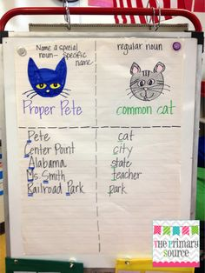
 | Higher Order Questions  List questions and identify level of taxonomy. The questions must be grade level appropriate and ABOVE the comprehension/understanding level.  http://www.fctl.ucf.edu/teachingandlearningresources/coursedesign/bloomstaxonomy/ |  | Why do you think proper nouns must have a capital letter? (Application)  Compare and contrast these two words: city, Lakeland. Which one is common and which is proper? How do you know? (Analysis)
 | Formative Assessment  Check for P-12 student learning and adjust instruction if necessary.  Examples: student response to questions, journal entries, graphic organizers, small group discussions with teacher notes, kinesthetic assessments, white board responses, exit slips, Kagan strategies, etc  If using Plickers, Kahoot, etc., provide the link and/or hard copy of the questions.  What evidence will you collect from p-12 student's to demonstrate that they learned the critical content of the required standards and met the learning targets?  Feedback: How will you provide feedback to P-12 students and celebrate success? |  | I will be checking to see that all students are copying the graphic organizer and placing the words in the right columns. I will walk around and guide students who are having difficulty and praise those who are putting the words in right columns.
Guided Practice/Exploration  When using the 5E model, Explanation and Exploration are reversed.  - Paired or group activities  - Practice  - Feedback from peers and teacher  What practice opportunities will you provide to impact student learning? | List the FL Standard(s) and learning target(s) in this section:  LAFS.1.L.1.2 Demonstrate command of the conventions of standard English capitalization.  Capitalize dates and names of people. |  |  |  |  | Estimated Time:  10 min
Common vs Proper noun journal insert Page 1 Completed
together - projected on screen

Fill in the blank journal entry:
Page 1
A common noun is a person, place, or thing A proper noun names
a person place or thing proper nouns always begin with
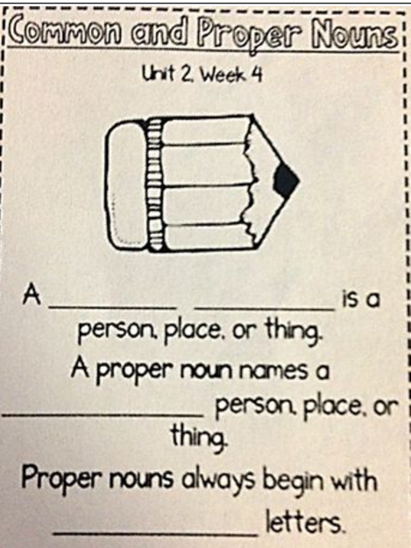
capital letters.
Page 2: Completed individually or with the help of a partner
Read instructions on sheet Go over top half of sheet together.
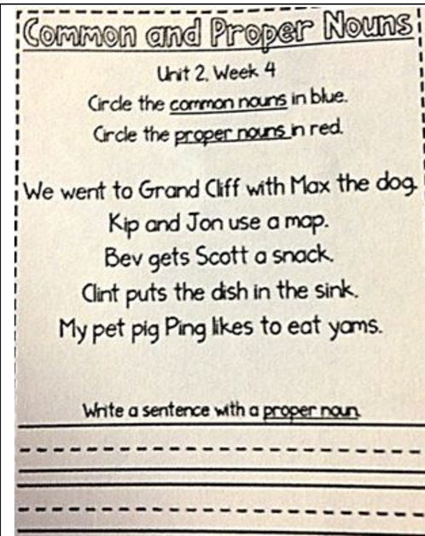

 | Higher Order Questions  List questions and identify level of taxonomy. The questions must be grade level appropriate and ABOVE the comprehension/understanding level.  http://www.fctl.ucf.edu/teachingandlearningresources/coursedesign/bloomstaxonomy/ |  | Create your own sentence using a proper noun. (Synthesis)
 | Formative Assessment  Check for student learning and adjust instruction if necessary.  Examples: student response to questions, journal entries, graphic organizers, small group discussions with teacher notes, kinesthetic assessments, white board responses, exit slips, Kagan strategies, etc…  If using Plickers, Kahoot, etc… Provide the link and/or hard copy of the questions.  What evidence will you collect from p-12 student's to demonstrate that they learned the critical content of the required standards and met the learning targets?  Feedback: How will you provide feedback to P-12 students and celebrate success? |  | I will walk around the room and check to see if students know common and proper nouns on the journal sheets. I will help students who are having trouble and praise those who are mastering the concept. I will also note those having trouble in my binder so I can continue to monitor them and remediate as needed.
Independent Practice/Elaboration  Application of the objectives and learning targets.  - P-12 students work independently to provide data to adapt instruction in wrap-up and remediation  - PST assesses individual P-12 student learning  What individual practice will you provide to impact P-12 student learning? | List the FL Standard(s) and learning target(s) in this section:  LAFS.1.L.1.2 Demonstrate command of the conventions of standard English capitalization.  Capitalize dates and names of people. |  |  |  |  | Estimated Time:  5 min
 | Students will be asked to create their own sentence using common and proper nouns, and be able to identify where the common and proper nouns are within the sentence. Each common noun will be underlined once. Each proper noun will be circled.
Wrap-up/Closure  Review the objective(s) using P-12 student-engaged activities:  - Higher Order Questions  - Exit tickets  - Additions to the KWL  - Post-It Notes  - Etc…..  What wrap-up will you provide to impact P-12 student learning? | List the FL Standard(s) and learning target(s) in this section:  LAFS.1.L.1.2 Demonstrate command of the conventions of standard English capitalization.  Capitalize dates and names of people. |  |  |  |  | Estimated Time:  10 min.
Bring students to carpet. I’m going to read some words and you are going to decide if the
noun is common or proper. Once you decide you are going to write a P if it is proper, or a c if it is common on your white board. Then hold up your boards to let me see your answer.
Once I give you the ok you may put your board down and erase it so you are ready for the next word.

Words:
city- c
fish-c
Ms. Smith-p
flower- c
Rose- P
Frankenstein- P
monster- c
explorer- c
Christopher Columbus-P
boat -c
cat -c
Mayflower-c
Pete-c

What is a common noun? Talk with a partner and tell them
three different common nouns you know.

What is a proper noun? Talk with a different partner and tell
them three different proper nouns you know.
 | Higher Order Questions  List questions and identify level of taxonomy. The questions must be grade level appropriate and ABOVE the comprehension/understanding level.  http://www.fctl.ucf.edu/teachingandlearningresources/coursedesign/bloomstaxonomy/ |  | Is mouse a common or proper noun? How do you know? (Evaluation)  Is Mickey Mouse a common or proper noun? How do you know? (Evaluation)
 | Formative Assessment  Check for P-12 student learning and adjust instruction if necessary.  Examples: P-12 student response to questions, journal entries, graphic organizers, small group discussions with teacher notes, kinesthetic assessments, white board responses, exit slips, Kagan strategies, etc  If using Plickers, Kahoot, etc., provide the link and/or hard copy of the questions.  What evidence will you collect from p-12 student's to demonstrate that they learned the critical content of the required standards and met the learning targets?  Feedback: How will you provide feedback to P-12 students and celebrate success? |  | I will look at the white board answers given to make sure the students can tell the difference between a common and proper noun. I will note those who are struggling and call them to the back table for remediation during our study time.
Summative Assemnt/ Evaluation  This must assess the P-12 students’ mastery of the FL Standard and learning targets. Examples: final project, paper test, report, chapter test, etc.  Attach a copy of the summative assessment to this lesson plan. | 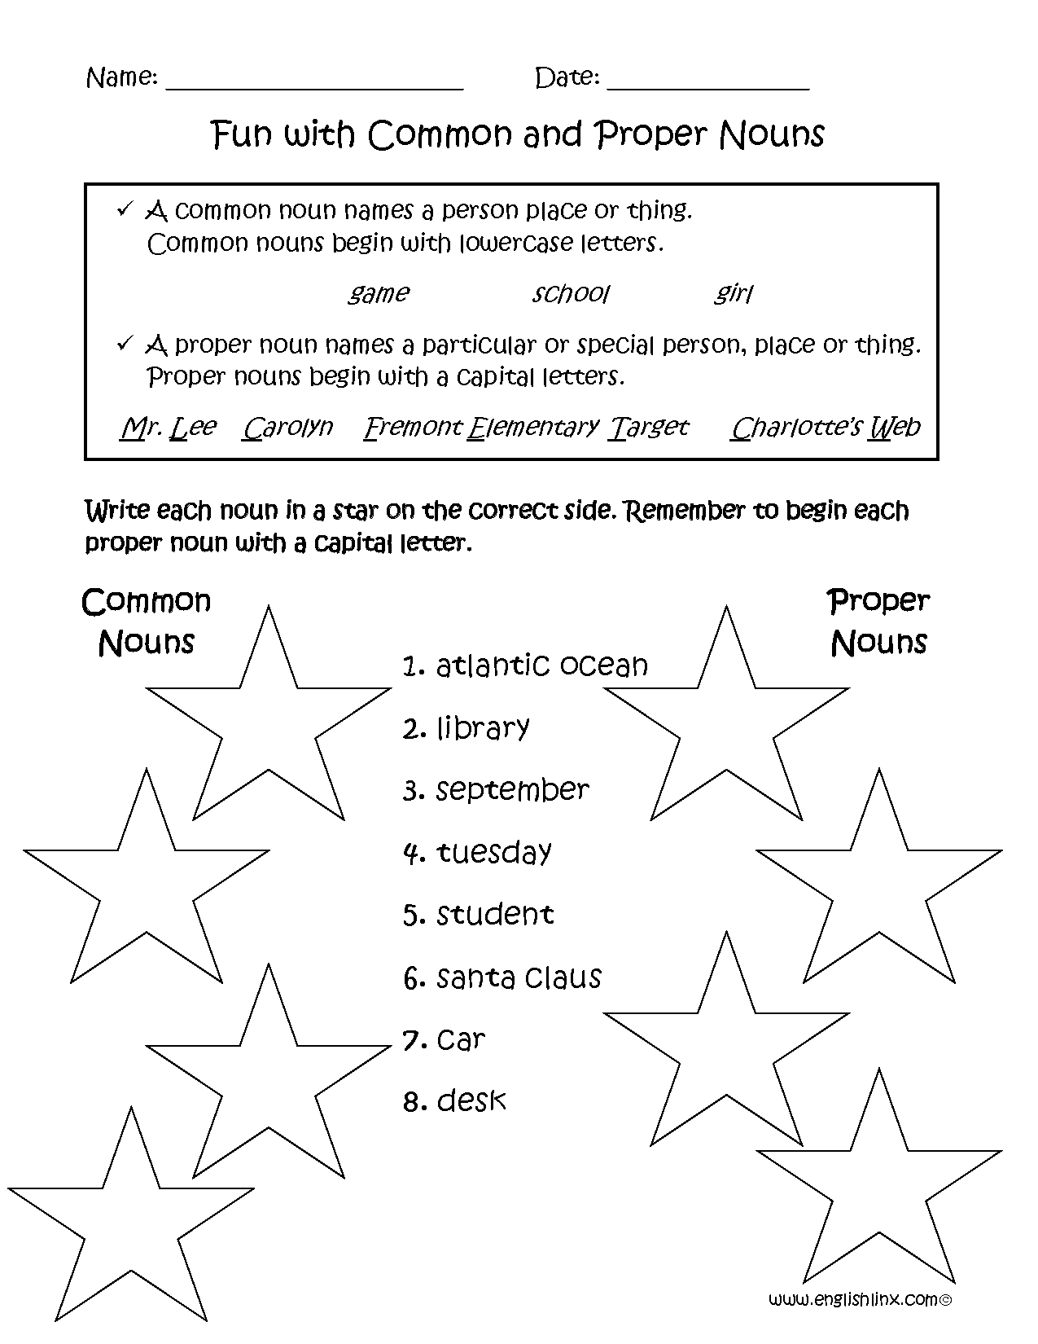 |  |  |  |  | Estimated Time:  10 min.
Remediation  What will YOU do with the P-12 students who do not meet the mastery measurement level provided in the FL Standard/summative assessment?  - Provide a detailed explanation  - Include additional materials used for remediation | Students who do not reach mastery level 6/8 or 75% will come to the back table with me during study time and we will use index cards with both common nouns and proper nouns written on them. We will use them to sort into the two categories. At first the proper nouns will be capitalized. Then, we will use a new deck where they are not capitalized so the students have to think about whether or not the noun names a certain person, place or thing.
Resources for development and implementation of lesson | Cpalms  Grade level planning meeting  Professional development at school  Observation of another teacher  Websites (list)  Cooperating teacher  Supervising professor  Coursework  Other

